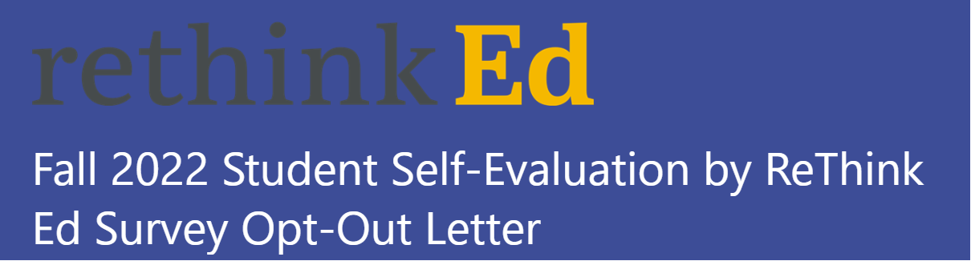

The School Counseling Department gathers input on how students are doing with Life Skills, Student Success Skills, and Social & Emotional Learning (SEL). Students are asked to reflect on their competencies in the areas of self-awareness, self-management, decision making, and interpersonal skills that are vital for school, work, and life success to plan effective SEL instruction. The data from these brief surveys, which will include the student’s name, date of birth, gender, race, ethnicity, grade level, school location, identification number, course assignments, Special Education classification, English for Speakers of Other Languages, and student rosters, will solely be used by authorized BCPS staff and partners to direct school activities and provide SEL services to students.

The SEL sample surveys for 4th - 12th grade and instructional materials can be viewed by scheduling an appointment with your school’s SEL Liaison. Additional parent/guardian information can be found on the School Counseling website. Other resources and strategies on how to incorporate SEL at home can be found in our SEL & Mindfulness Toolkit for Families and Students.

Please let us know if you would like your child to NOT take the survey by filling out the bottom portion of this Forms by October 5, 2022. Click the [SURVEY](https://forms.office.com/Pages/ResponsePage.aspx?id=y7Ws7nBTWEOpaqN4PJXUIi8osRm_iZNAmxiwZguUlmVUNlIzMDUxTThNSExYQ1ZOOUhZNlNWSlE1MS4u). If you have any questions or comments, please contact Belinda Daise, the SEL Supervisor, at Belinda.Daise@browardschools.com.

Sincerely,

Belinda Daise